How DHCP works Explained with Examples
When a host (DHCP client) needs an IP configuration, it connects to a DHCP server and requests an IP configuration. A DHCP server contains several pre-configured IP configurations. When it receives a DHCP request from a DHCP client, it provides an IP configuration to the client from all available IP configurations.
This process goes through four steps: Discover, Offer, Request, and Acknowledgment.
The following image shows all four steps of a DHCP communication.
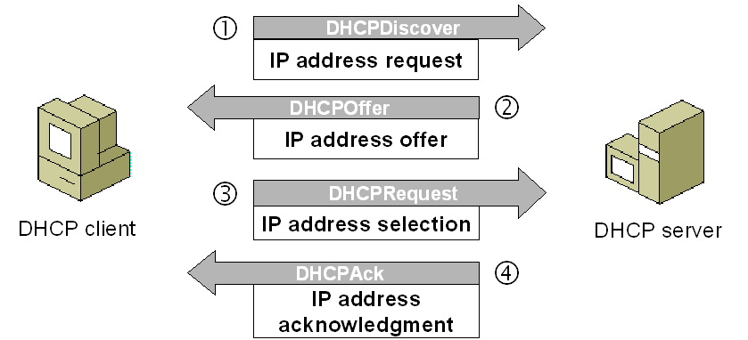

DHCP discovery
When we start a device, it checks whether a valid IP configuration is available. If it is not available, the device generates a special message known as the DHCPDISCOVER message and broadcasts this message on the local LAN segment.
In this message, the device uses the addresses 0.0.0.0 and 255.255.255.255 in the source and destination address fields, respectively.
The 0.0.0.0 and 255.255.255.255 are two special addresses. Any device, whether it has a valid IP configuration or not, can use these addresses to send local broadcast messages.
From these addresses, the 0.0.0.0 is used as the source address. If a device does not have the source address, it can use this address to send broadcast messages. 255.255.255.255 is the local broadcast address. Any message sent to this address is received by all hosts of the local network.

DHCP offer
Since the client sends the DHCPDISCOVER message to the local broadcast address, if a DHCP server is configured on the local network, it will also receive the message. If multiple DHCP servers are configured on the local network, they all will receive the DHCPDISCOVER message.
If multiple DHCP servers are available, based on their configuration, one of them or all of them can reply to the DHCPDISCOVER message. In reply to the DHCPDISCOVER message, a DHCP server sends a DHCPOFFER message to the client.
Since the client does not have an IP address, the DHCP server cannot send the DHCPOFFER message directly to the client. Because of this, the server sets the destination address to 255.255.255.255. In other words, the server also broadcasts the DHCPOFFER message to the local network.
The DHCPOFFER message includes protocol-specific information and an IP address, subnet mask, default gateway's IP address, DNS server's IP address, and other configured servers' IP addresses such as TFTP and FTP.
Apart from these, the DHCPOFFER message also contains other protocol-specific information such as the lease duration and client ID. This information is required by the core functions of DHCP.

DHCP request
All hosts in the local network receive the DHCPOFFER message. The host that sent the DHCPDISCOVER message accepts the DHCPOFFER message. Apart from the original host, all other hosts ignore the DHCPOFFER.
How does a host know whether the broadcasted DHCPOFFER message is for it?
The DHCPDISCOVER message contains the host's MAC address. When a DHCP server broadcasts a DHCPOFFER message, it also includes the host's MAC address in a parameter known as the client ID. When hosts receive the DHCPOFFER message, they check the client ID field in the message. If a host sees its MAC address in the client ID field, it knows the message is intended for it. If a host sees the MAC address of another host in the client ID field, it knows the message is not intended for it.
Depending on the number of DHCP servers, a host may receive multiple DHCPOFFER messages. If a host receives multiple DHCPOFFER messages, it accepts only one message and tells the corresponding server with a DHCPREQUEST message that it wants to use the offered IP configuration.
If only one DHCP server is available and the provided IP configuration conflicts with the client’s configuration, the client can respond with a DHCPDECLINE message. In this situation, the DHCP server offers another IP configuration.
When DHCP servers receive the DHCPREQUEST message, besides the server whose offer has been accepted, all other servers withdraw their offer and return them to the pool of available addresses.
The DHCPREQUEST message contains a Transaction ID field. Just like hosts use the client ID field of the DHCPOFFER message to know whether the message is intended for them or not, DHCP servers use the Transaction ID field of the DHCPREQUEST message to know whether their offer has been accepted or not.

DHCP acknowledgment
When the DHCP server receives a DHCPREQUEST message from the client, the configuration process enters its final stage. In this stage, the server sends a DHCPACK message to the client.
The DHCPACK message is an acknowledgment to the client indicating that the DHCP server has received the DHCPREQUEST message of the client, and the client can use the offered IP configuration.
In some cases, the server may also respond with a DHCPNACK message. The DHCPNACK message tells the client that the offer is no longer valid and the client needs to request an IP configuration again. Typically, this occurs when the client takes too long to respond with a DHCPREQUEST message after receiving a DHCPOFFER message from the server. In such a case, the client can make a new request for another IP configuration.
The following image shows the above steps.
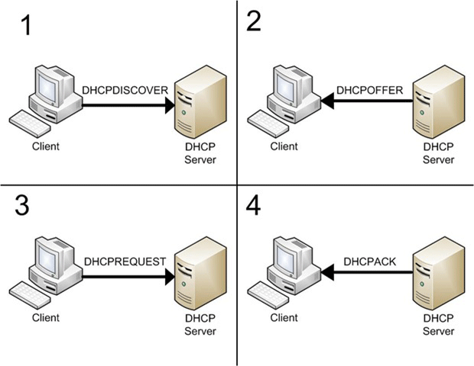
The following table summarizes messages that are used in each stage.
Discover | The DHCP client broadcasts this message to find a DHCP server.
Offer | The DHCP server broadcasts this message to lease an IP configuration to the DHCP client.
Request | The DHCP client uses this message to notify the DHCP server whether it accepts the proposed IP configuration or not.
Acknowledgment | The DHCP server uses this message to confirm to the DHCP client that it can use the offered IP configuration.
An easy way to remember these messages in the correct order is to think of the popular children's show "Dora the Explorer".

How to Configure DHCP Server on Cisco Switches
The DHCP service allows hosts to automatically obtain their IP configuration from the DHCP server. The DHCP service is available on Cisco switches. If you have a Cisco switch in your network, you can also use it as a DHCP server.
The following table lists the commands that are required to configure a switch to act as a DHCP server.
Command | Description (command used for)
Switch>enable | To enable the switch and to enter privileged-exec mode.
Switch#configure terminal | To enter global configuration mode.
Switch(config)#ip dhcp excluded-address [starting address] [ending address] | To create a range of excluded IP addresses.
Switch(config)#ip dhcp pool [pool name] | To create a DHCP pool and enter DHCP pool configuration mode.
Switch(dhcp-config)#network [network ID] [subnet mask] | To define the range of IP addresses that the DHCP server should offer to clients.
Switch(dhcp-config)#default-router [IP address of default gateway] | To set the IP address of the default gateway.
Switch(dhcp-config)#dns-server [IP address of DNS server] | To set the IP address of the DNS server.
Switch(dhcp-config)#exit | To exit DHCP pool configuration mode.
Switch(config)#interface vlan 1 | To enter VLAN configuration mode of the VLAN 1.
Switch(config-if)#ip address [any available IP address from the pool] [subnet mask] | To set an IP address on the VLAN1.
Switch(config-if)#no shutdown | To enable the VLAN.
Switch(config-if)#exit | To exit VLAN configuration mode.
Switch(config)#exit | To exit global configuration mode.
Switch#copy running-config startup-config | To copy running configuration to startup configuration.
Before we learn how to use the above commands in detail, I assume that you are familiar with DHCP terminology and configuration. To know what DHCP is and how it works, please check the previous parts of this tutorial.
This tutorial is the fourth part of the tutorial 'DHCP (Dynamic Host Configuration Protocol) basic concepts, configurations, functions, and options Explained'. Other parts of this tutorial are the following.
What DHCP is and Types of DHCP Explained
How DHCP works explained with examples
DHCP Configuration Parameters and Settings Explained
Configure DHCP Server for multiple VLANs on the Switch
How to Configure DHCP Server on Cisco Routers
How DHCP Relay Agents work Explained
How to Configure DHCP Relay Agent on Cisco Routers
How DHCP Snooping works Explained
Configure DHCP Snooping on Cisco Switches

DHCP configuration on Cisco switches (Packet Tracer example)
Either download the following pre-created practice lab or create a packet tracer lab to replicate the network explained below.
Download link of the pre-created practice lab
In a small network, a Cisco switch and a generic wireless access point are used to provide connectivity between hosts. Wired hosts are directly connected to the switch. Wireless hosts are connected to the access point and the access point is connected to the switch.
The following image shows this network.
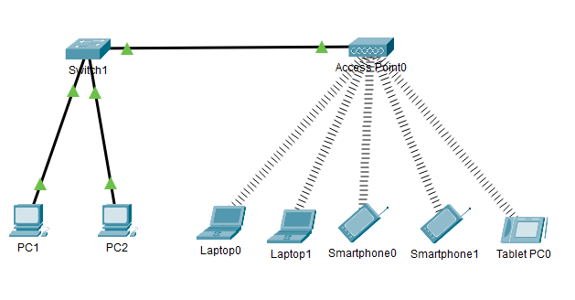

Objective
Configure the switch to act as the DHCP server.

Configuring DHCP service on the switch
Access the command prompt of the switch and run the following commands.
Switch>enable
Switch#configure terminal
Switch(config)#ip dhcp excluded-address 192.168.1.1 192.168.1.10
Switch(config)#ip dhcp pool test
Switch(dhcp-config)#network 192.168.1.0 255.255.255.0
Switch(dhcp-config)#default-router 192.168.1.1
Switch(dhcp-config)#dns-server 4.4.4.4
Switch(dhcp-config)#exit
Switch(config)#interface vlan 1
Switch(config-if)#ip address 192.168.1.5 255.255.255.0
Switch(config-if)#no shutdown
Switch(config-if)#exit
Switch(config)#exit
Switch#
The following image shows how to execute the above commands on the switch.
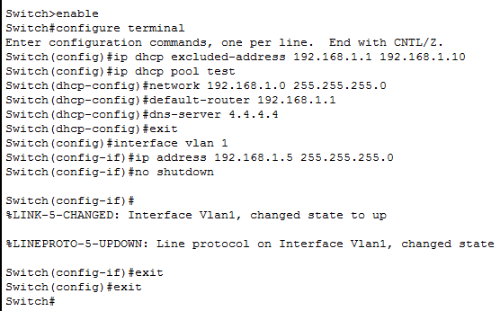
Let's understand the above configuration.
First, we created a range of reserved IP addresses (192.168.1.1 - 192.168.1.10). We use reserved addresses for the resources that need a static IP configuration such as routers, servers, and printers, etc.
After this, we created the pool named test and defined a range of all available IP addresses (192.168.1.0 255.255.255.0). This IP range also includes the reserved IP addresses that we excluded in the first step.
When the DHCP server provides IP addresses, it automatically excludes the reserved IP addresses from all available IP addresses.
Then, we set the default gateway and DNS server IP addresses.
Finally, we assigned an IP address from the reserved IP address to the Vlan 1 and enabled the Vlan 1.
DHCP uses the source IP address to determine the pool from which it should offer the IP address. Since a DHCP client does not have an IP address, DHCP uses the client's Vlan IP address to determine the IP pool for it.
The client's Vlan is the Vlan that is configured on the switch port that is connected to the client. For example, if a client is connected to the port F0/5 and Vlan 10 is configured on the port F0/5, then the client's vlan will be Vlan 10.
By default, all switch ports belong to VLAN 1. This means, unless you create or configure additional VLANs, DHCP will use VLAN1's IP address to determine the pool.
Since we assigned an IP address to VLAN 1 from our configured pool and did not create any additional VLAN, DHCP will use our pool to assign IP addresses to all clients.
VLAN is a switch management feature. It allows us to manage switch remotely, categorize connected hosts, and do a lot of extra stuff. To learn more about the VLAN, you can check the following tutorial.
VLAN Basic Concept Explained with Examples

Configuring DHCP clients
To configure a host as a DHCP client, change the host's IP configuration option to DHCP. For this, click the device and click the Desktop option and click the IP configuration and select the DHCP option.
The following image shows this procedure step-by-step on packet tracer.
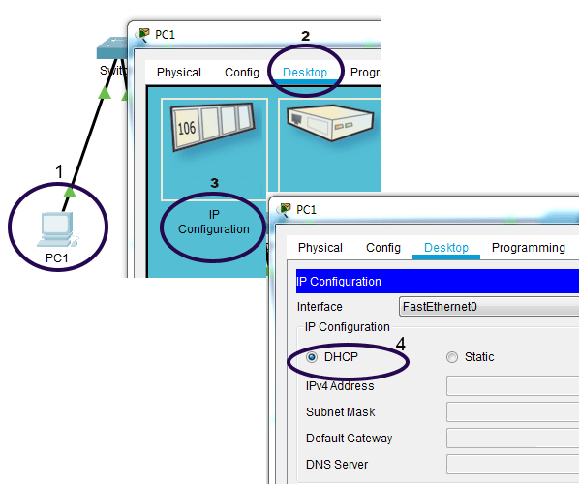
Configure all hosts as DHCP clients by following the above-explained steps.

Verifying DHCP server
To verify that the switch is properly configured as a DHCP server, you can check the IP configuration of any connected host.
To view the IP configuration of any host, click the host and click the Desktop option and click the IP configuration option and check the obtained IP configuration.
The following image shows these steps.
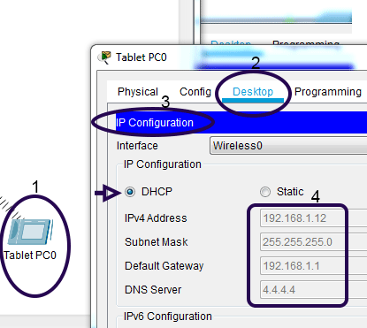
You can also use the 'ipconfig' command to view the IP address. To use the 'ipconfig' command, select the command prompt of the device and run this command.
The following image shows how to use this command.
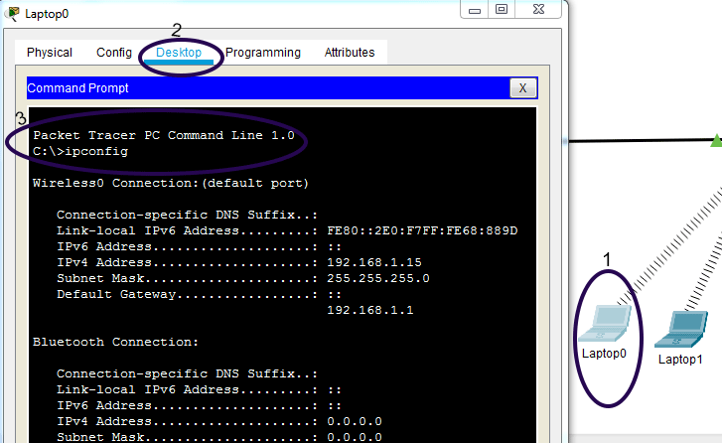

Viewing leased addresses and DHCP statistics
To view IP addresses leased by the DHCP server, use the 'show ip dhcp binding' command in privileged-exec mode.
The following image shows the output of this command.
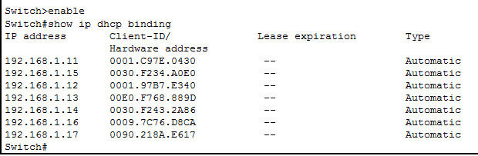
To view DHCP pool statistics and information, use the 'show ip dhcp pool [pool-name]' command. The following image shows the output of this command.
